# Average Daily Balance Calculator – Michael Ragsdale

## “Before” Usage Screen Shot

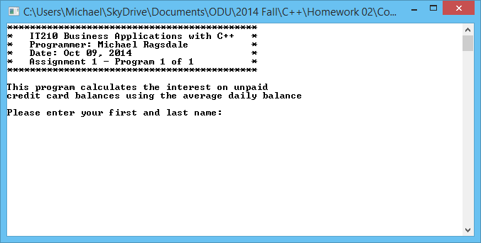

# Average Daily Balance Calculator – Michael Ragsdale

## “After” Usage Screen Shot

